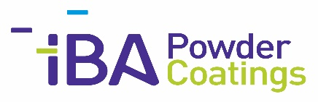
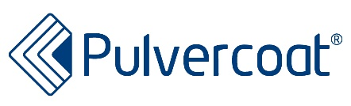
PRESS RELEASE

Category: Powder Coatings
IBA Kimya / Pulvercoat

ENHANCED SUSTAINABILITY AND REDUCED CARBON FOOTPRINT WITH IBALOWBAKE LOW-TEMPERATURE CURING POWDER COATINGS

Stuttgart, 05 February 2024
IBA Powder Coatings extends its range of polyester and epoxy/polyester powder coatings that cure at low temperatures, thus reducing energy consumption and operating costs and contributing to sustainability.
According to Wolfram Alber, Managing Director of Pulvercoat, the trend is to low-temperature curing powder coatings with special qualities. Together with IBA Kimya, Pulvercoat, its sales partner for the German speaking area, will present a large selection of these sustainable surfaces at the fair stand.
Hence, IBA Powder Coatings has developed solutions in respect of low-temperature curing powder coatings that would successfully replace conventional powder coatings in terms of physical and chemical characteristics.
Employees in research and development will advise visitors on these and all other individual solutions for surfaces of complex components. In addition, new design series of high-quality metallic coatings will be presented that are produced by our own premium bonding technology. Up-to-date design catalogues will be freely available.
IBA Kimya Sanayi ve Ticaret AS
www.iba.com.tr
info@iba.com.tr
Pulvercoat Vertrieb e.K.
Telephone +4971167428730
info@pulvercoat.de
www.pulvercoat.de
Halle 1, Stand 1138
(Press contact: Wolfram Alber)

